Tessellation
# Source: AI Source: Provided by: [Data Path: Persons Table -> ID Column: 1, Name_En Column: Motasem Essam] -> From: [ChatGPT] on [7/25/2026]
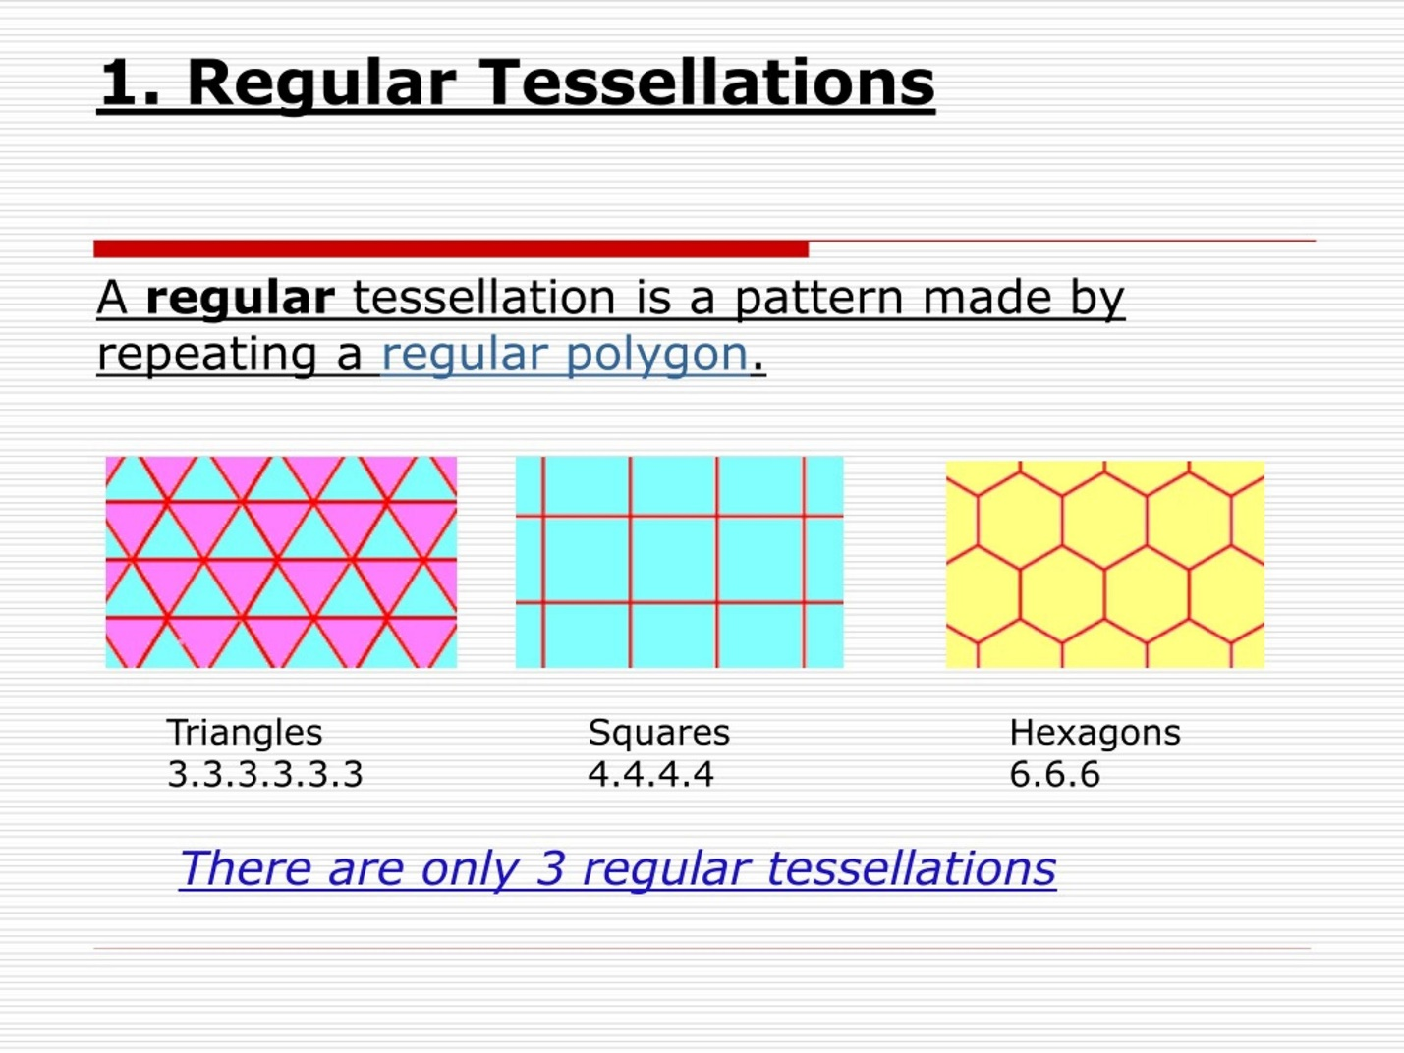
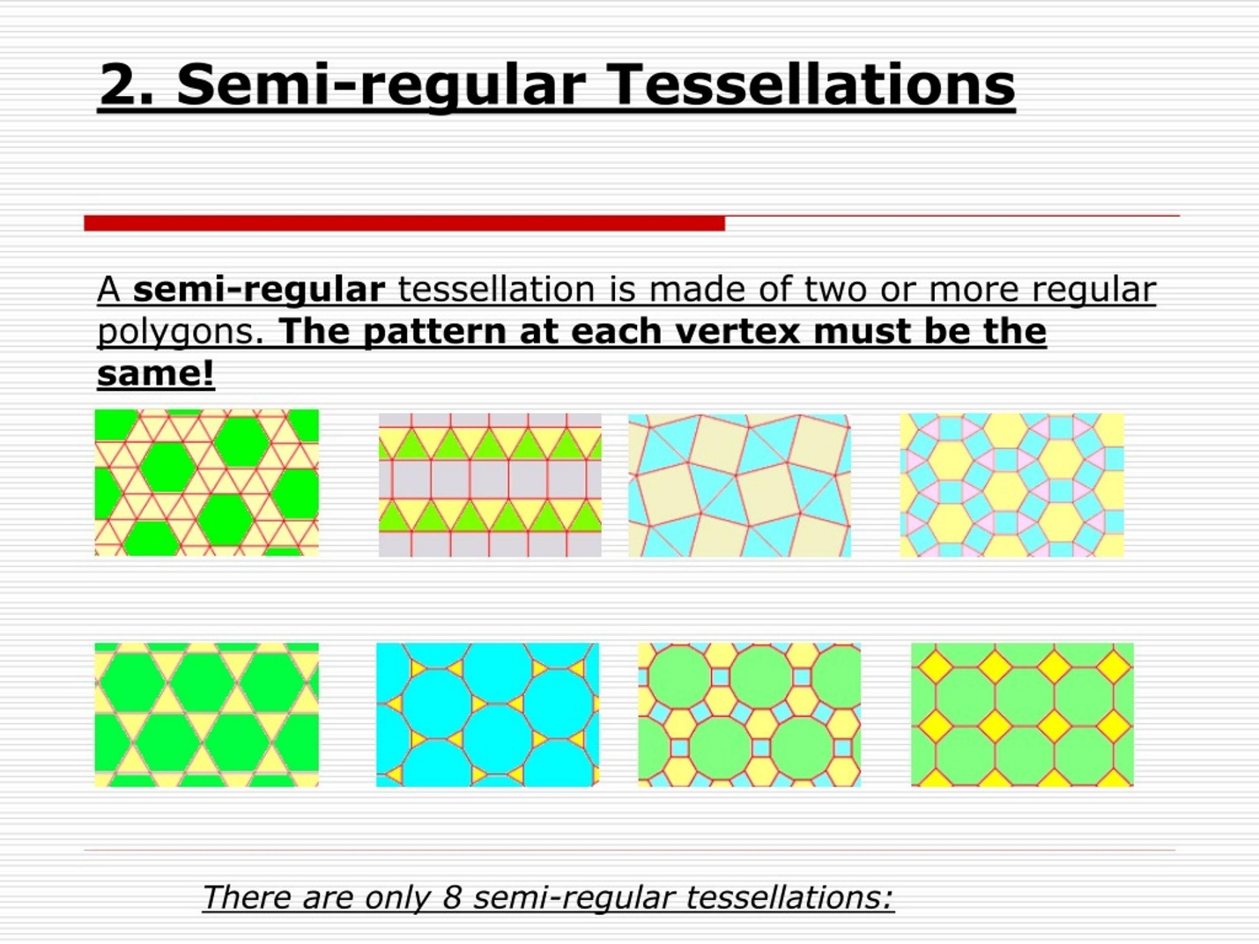
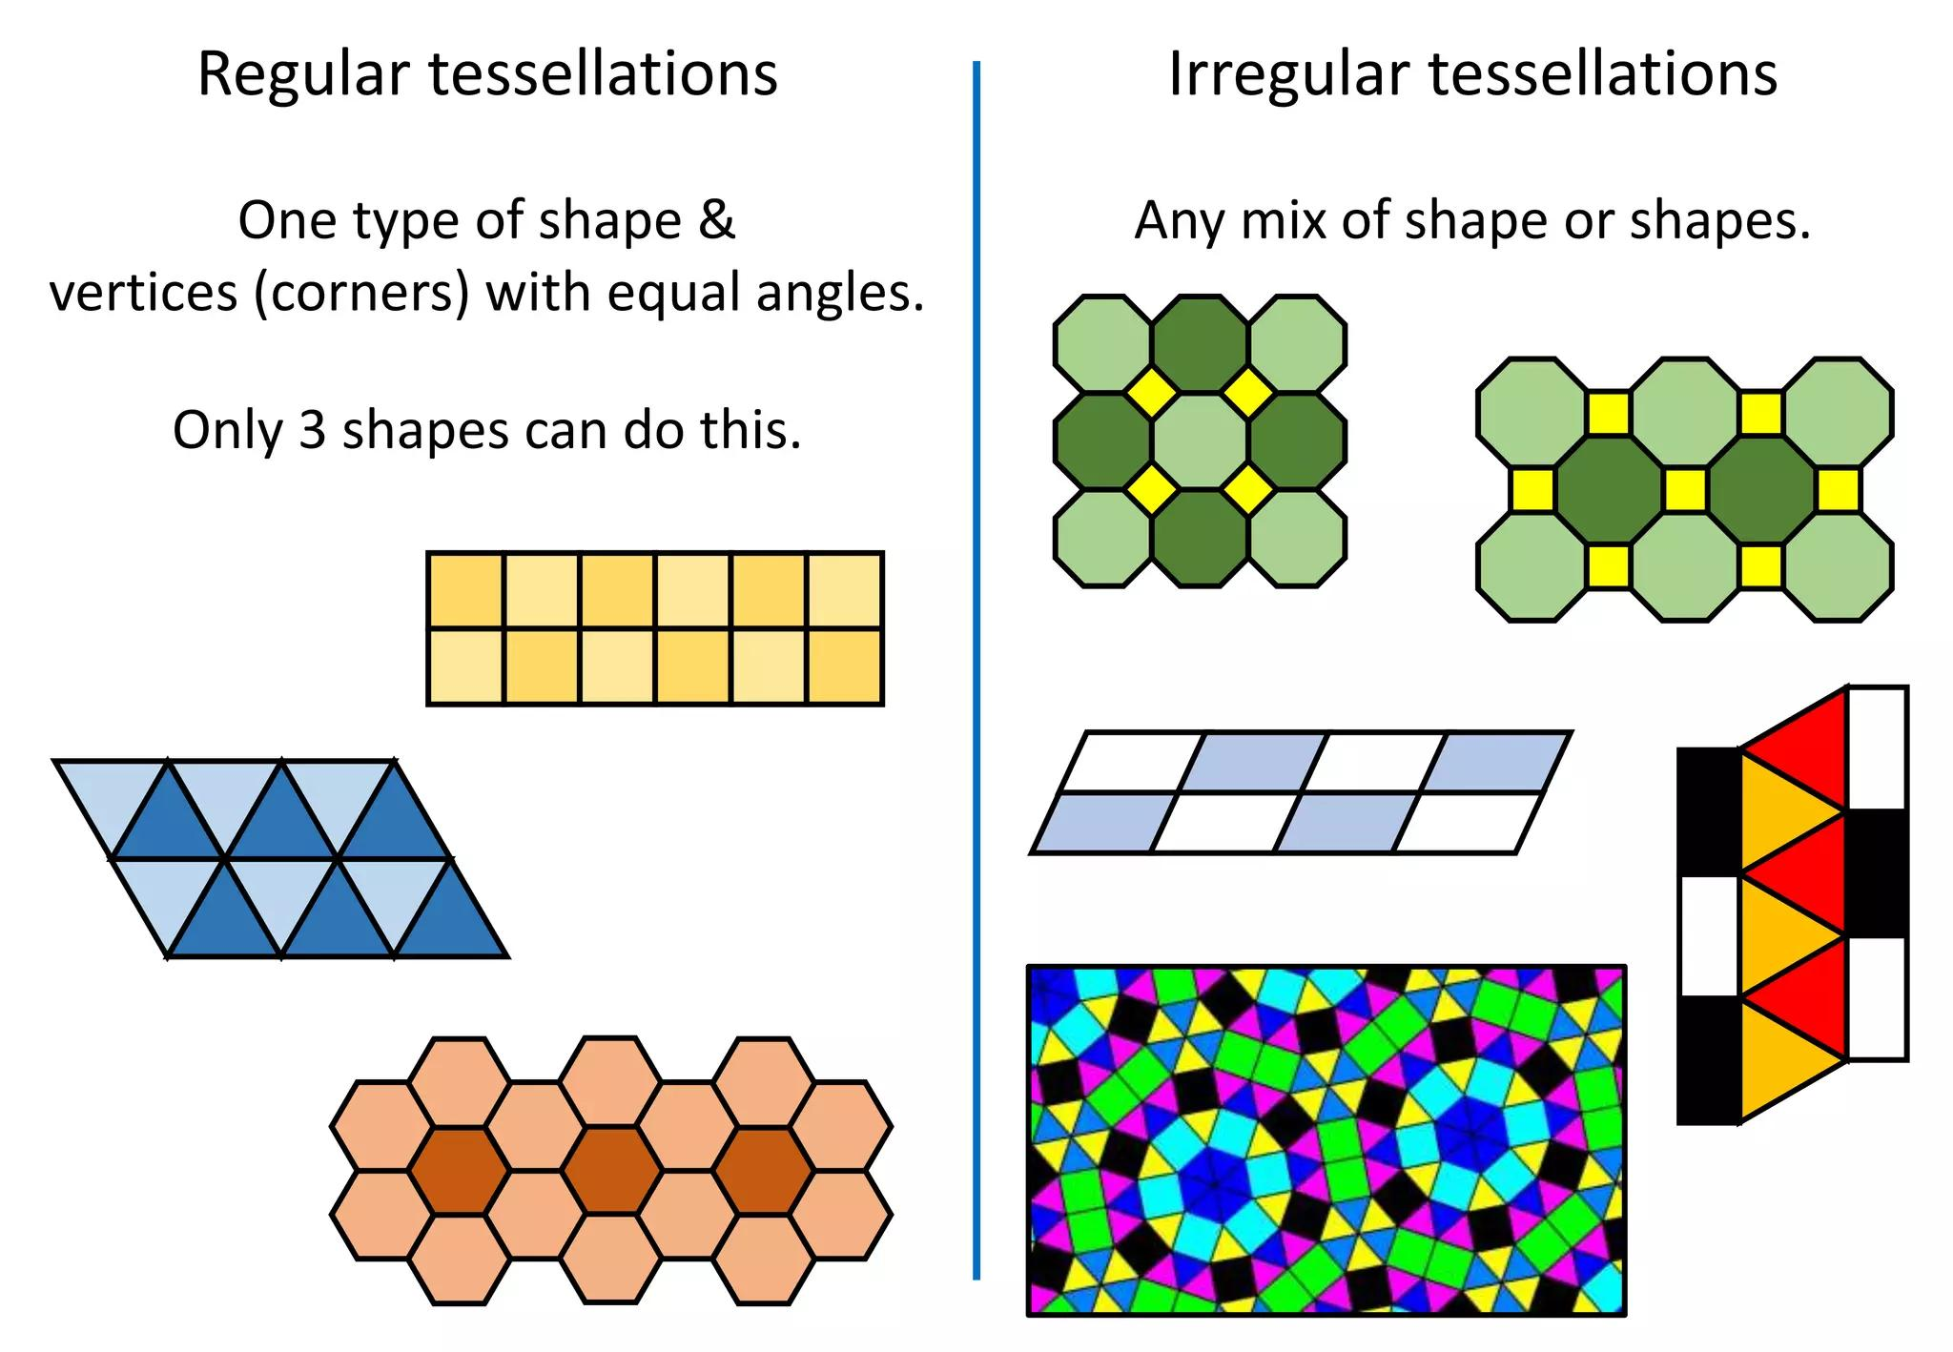
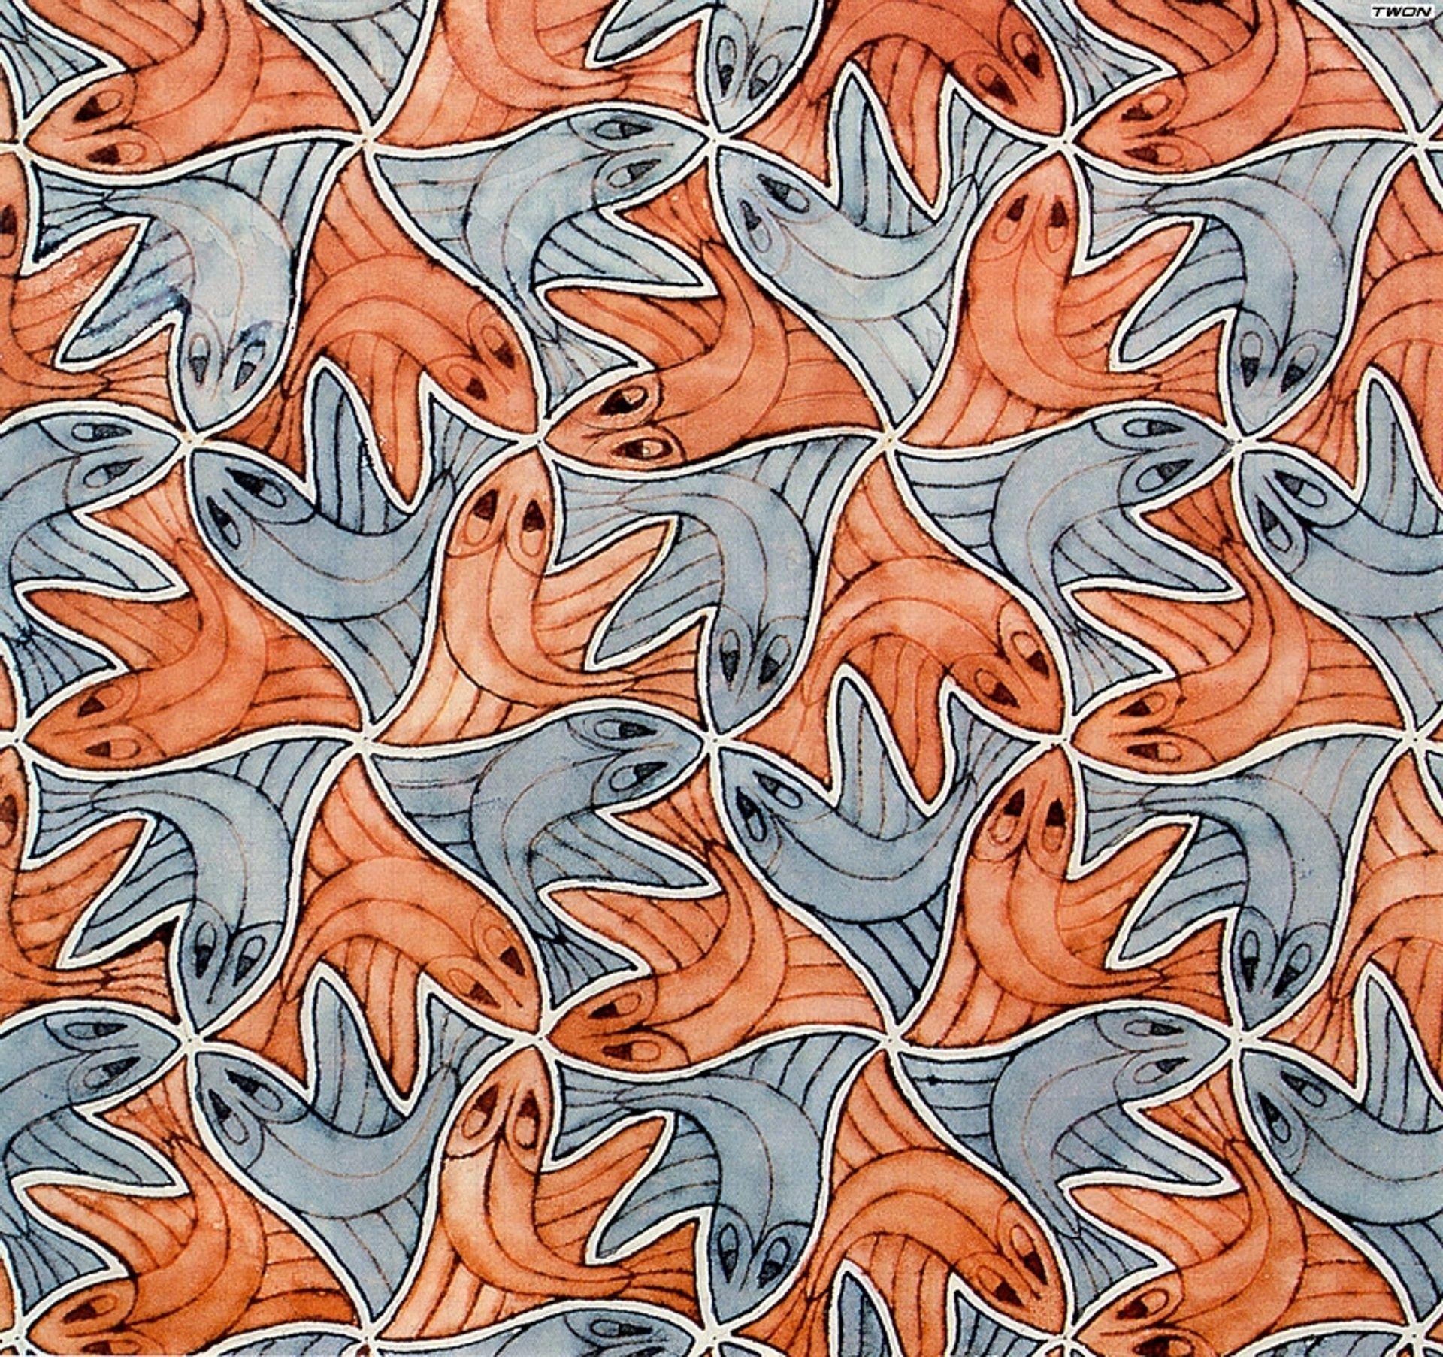
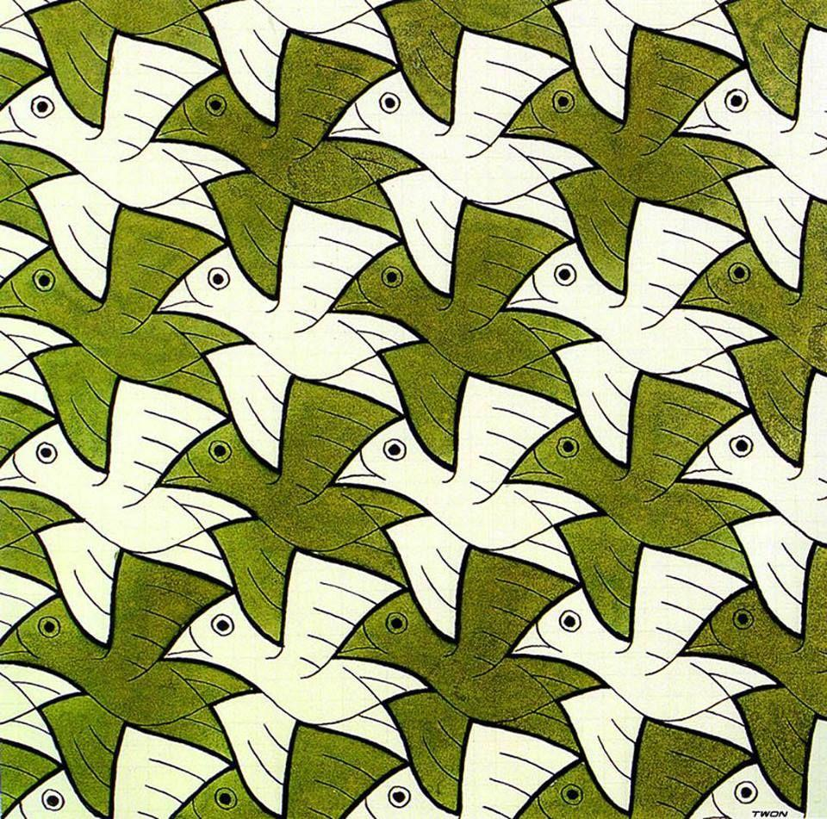
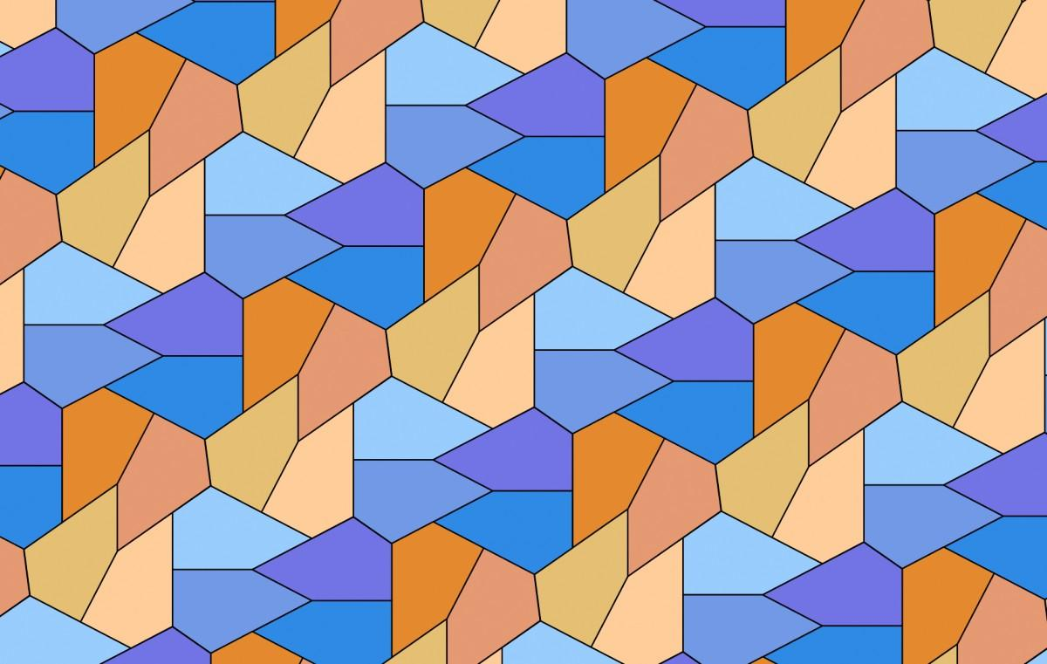

Definition
# Source: AI Source: Provided by: [Data Path: Persons Table -> ID Column: 1, Name_En Column: Motasem Essam] -> From: [ChatGPT] on [7/25/2026]
A Tessellation is a pattern formed by repeating one or more shapes so that they cover a plane completely without gaps or overlaps.
In a tessellation:
- The shapes fit together continuously.
- There are no gaps between tiles.
- There are no overlaps between tiles.
- The pattern can extend indefinitely across the plane.
The individual repeated shapes are often called tiles.

Purpose
# Source: AI Source: Provided by: [Data Path: Persons Table -> ID Column: 1, Name_En Column: Motasem Essam] -> From: [ChatGPT] on [7/25/2026]
Tessellations are used to:
- Study how geometric shapes fit together.
- Understand angles, polygons, and symmetry.
- Create repeating geometric patterns.
- Analyze plane coverings.
- Model arrangements used in architecture, art, and design.

Fundamental Elements

1. Tile
# Source: AI Source: Provided by: [Data Path: Persons Table -> ID Column: 1, Name_En Column: Motasem Essam] -> From: [ChatGPT] on [7/25/2026]
The tile is the basic shape that is repeated.
Examples:
- Triangle
- Square
- Hexagon
- Irregular polygon

2. Vertex
# Source: AI Source: Provided by: [Data Path: Persons Table -> ID Column: 1, Name_En Column: Motasem Essam] -> From: [ChatGPT] on [7/25/2026]
A vertex is a point where multiple tiles meet.

3. Edge
# Source: AI Source: Provided by: [Data Path: Persons Table -> ID Column: 1, Name_En Column: Motasem Essam] -> From: [ChatGPT] on [7/25/2026]
An edge is the boundary shared between adjacent tiles.

4. Pattern
# Source: AI Source: Provided by: [Data Path: Persons Table -> ID Column: 1, Name_En Column: Motasem Essam] -> From: [ChatGPT] on [7/25/2026]
The repeated arrangement of tiles across the plane forms the tessellation.

Fundamental Condition
# Source: AI Source: Provided by: [Data Path: Persons Table -> ID Column: 1, Name_En Column: Motasem Essam] -> From: [ChatGPT] on [7/25/2026]
For a tessellation of a plane, the tiles must cover the plane without gaps or overlaps.
At an ordinary interior vertex, the angles surrounding the vertex must satisfy:
$$\boxed{θ_{1}+θ_{2}+⋯+θ_{n}={360}^{∘}}$$
This is one of the most important conditions for determining whether polygons can form a tessellation.

Classification of Tessellations
# Source: AI Source: Provided by: [Data Path: Persons Table -> ID Column: 1, Name_En Column: Motasem Essam] -> From: [ChatGPT] on [7/25/2026]
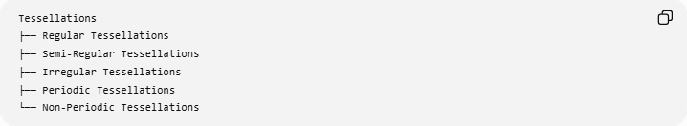
Tessellations
├── Regular Tessellations
├── Semi-Regular Tessellations
├── Irregular Tessellations
├── Periodic Tessellations
└── Non-Periodic Tessellations

1. Regular Tessellation
# Source: AI Source: Provided by: [Data Path: Persons Table -> ID Column: 1, Name_En Column: Motasem Essam] -> From: [ChatGPT] on [7/25/2026]
A Regular Tessellation uses only one type of regular polygon.
There are exactly three regular tessellations of the Euclidean plane:
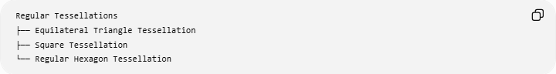
Regular Tessellations
├── Equilateral Triangle Tessellation
├── Square Tessellation
└── Regular Hexagon Tessellation
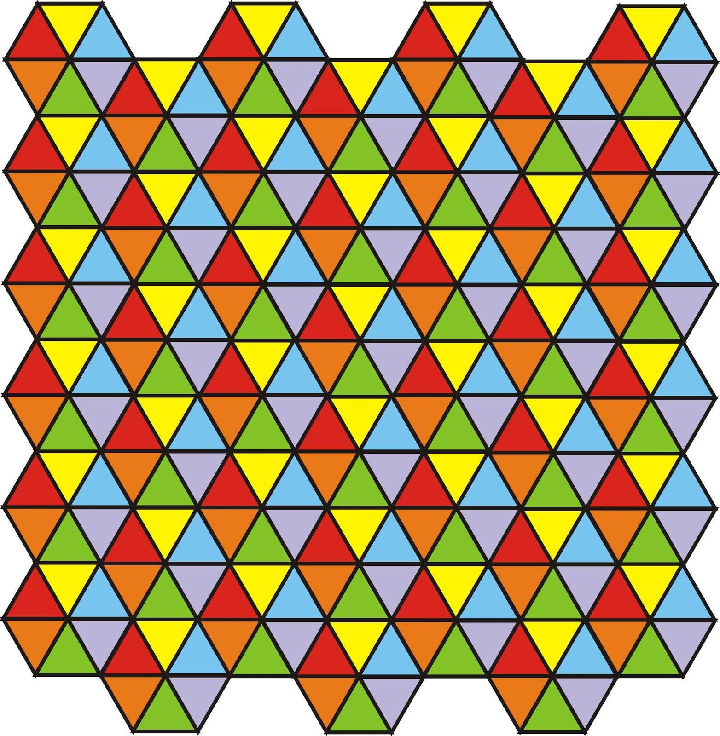
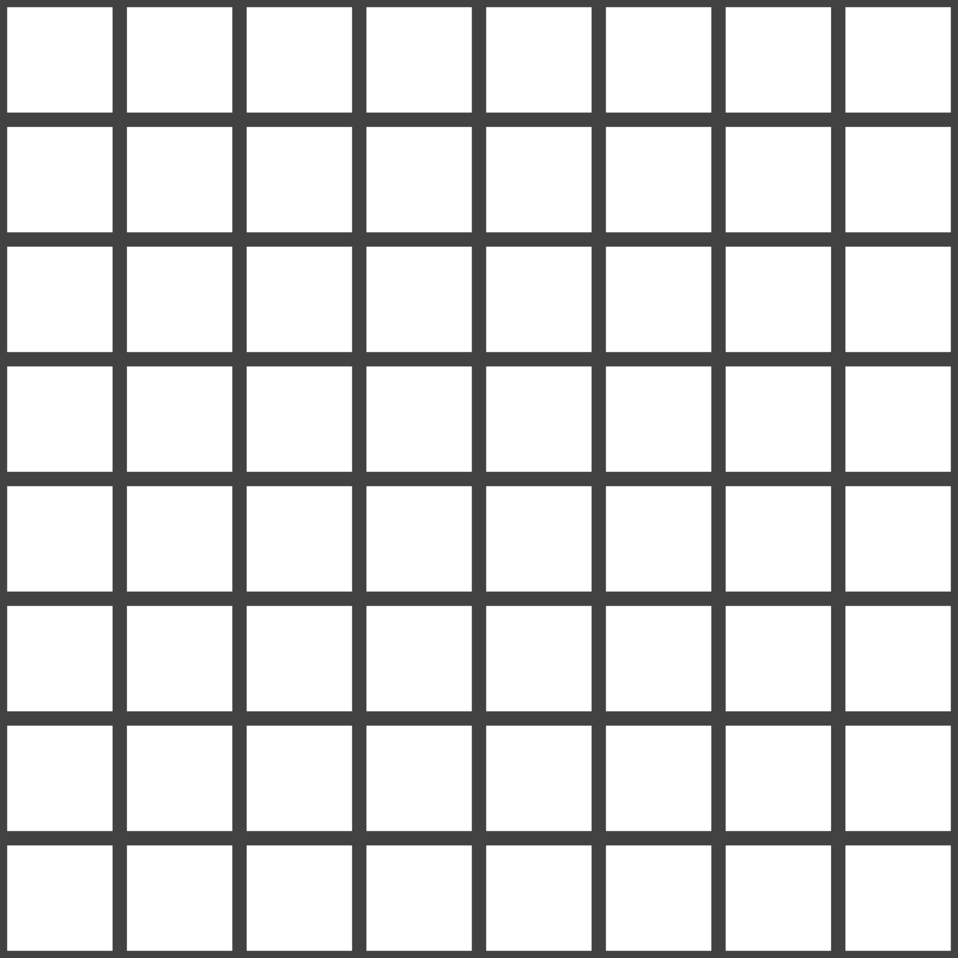
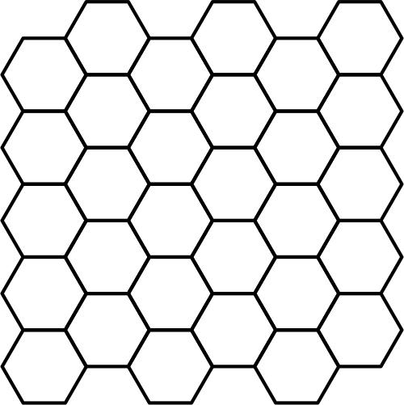
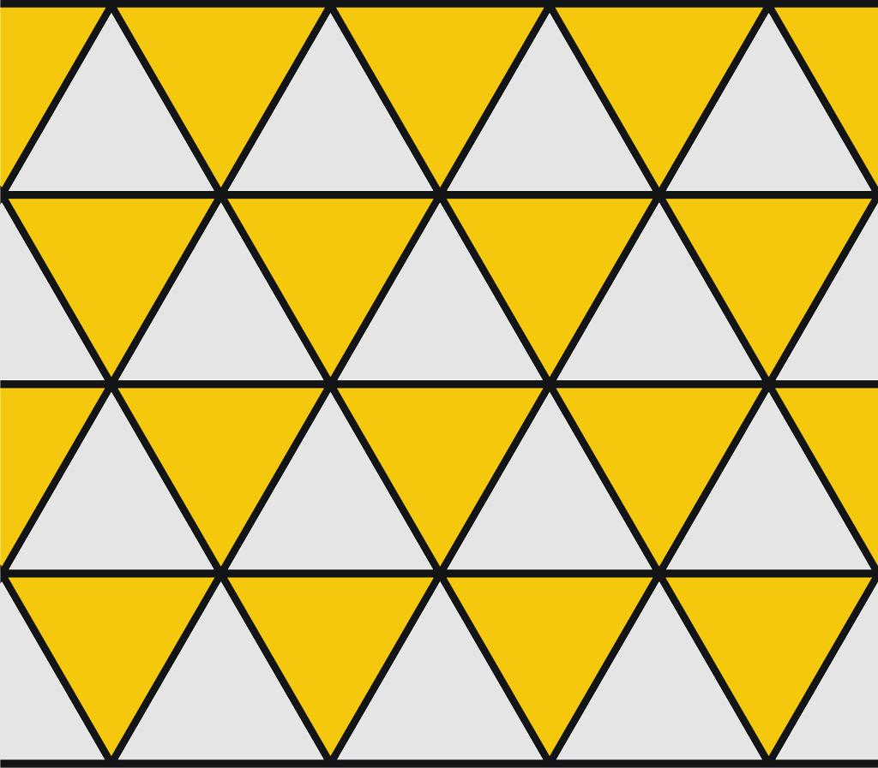
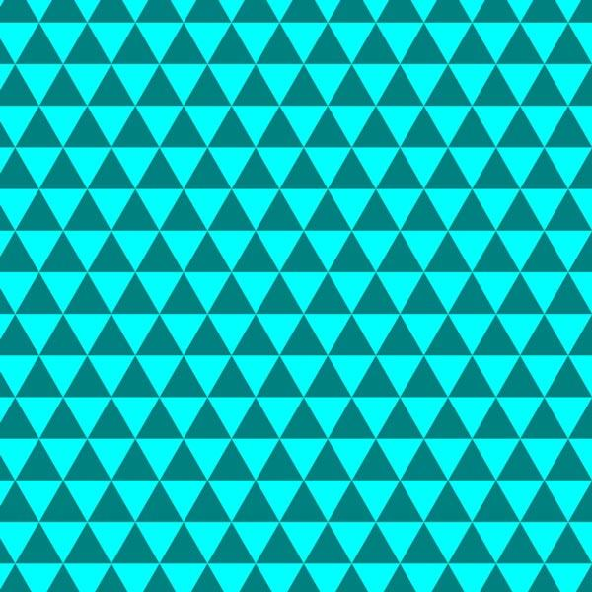
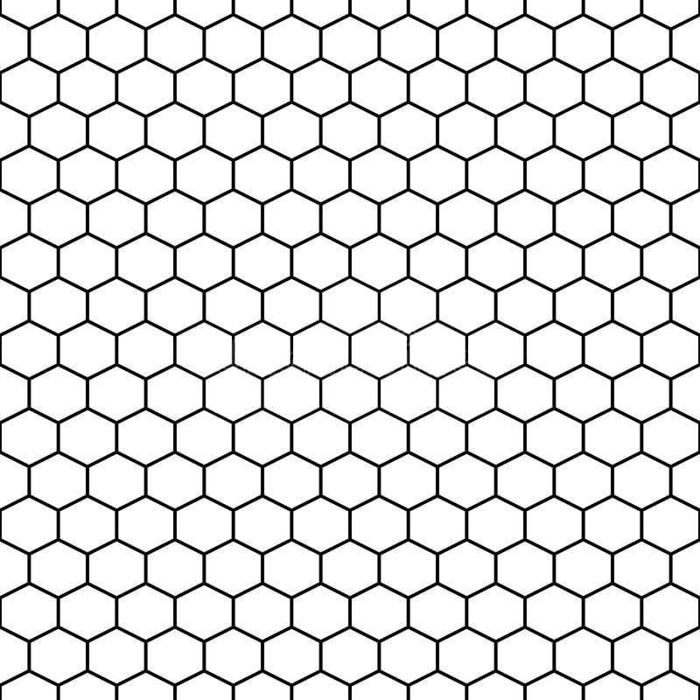
Equilateral Triangle Tessellation
Six equilateral triangles meet at each vertex:
$$6\left({60}^{∘}\right)={360}^{∘}$$
Square Tessellation
Four squares meet at each vertex:
$$4\left({90}^{∘}\right)={360}^{∘}$$
Regular Hexagon Tessellation
Three regular hexagons meet at each vertex:
$$3\left({120}^{∘}\right)={360}^{∘}$$

2. Semi-Regular Tessellation
# Source: AI Source: Provided by: [Data Path: Persons Table -> ID Column: 1, Name_En Column: Motasem Essam] -> From: [ChatGPT] on [7/25/2026]
A Semi-Regular Tessellation uses two or more types of regular polygons, with the same arrangement of polygons around every vertex.
Examples include combinations such as:
- Triangles and hexagons
- Squares and triangles
- Squares and octagons
A vertex configuration can be represented by the numbers of polygon sides surrounding each vertex.
For example:
$$\boxed{3.6.3.6}$$
means that triangles and hexagons alternate around each vertex.

3. Irregular Tessellation
# Source: AI Source: Provided by: [Data Path: Persons Table -> ID Column: 1, Name_En Column: Motasem Essam] -> From: [ChatGPT] on [7/25/2026]
An Irregular Tessellation uses polygons that are not necessarily regular.
Examples include:
- Irregular triangles
- Irregular quadrilaterals
- Irregular pentagons
- Mixtures of different irregular polygons
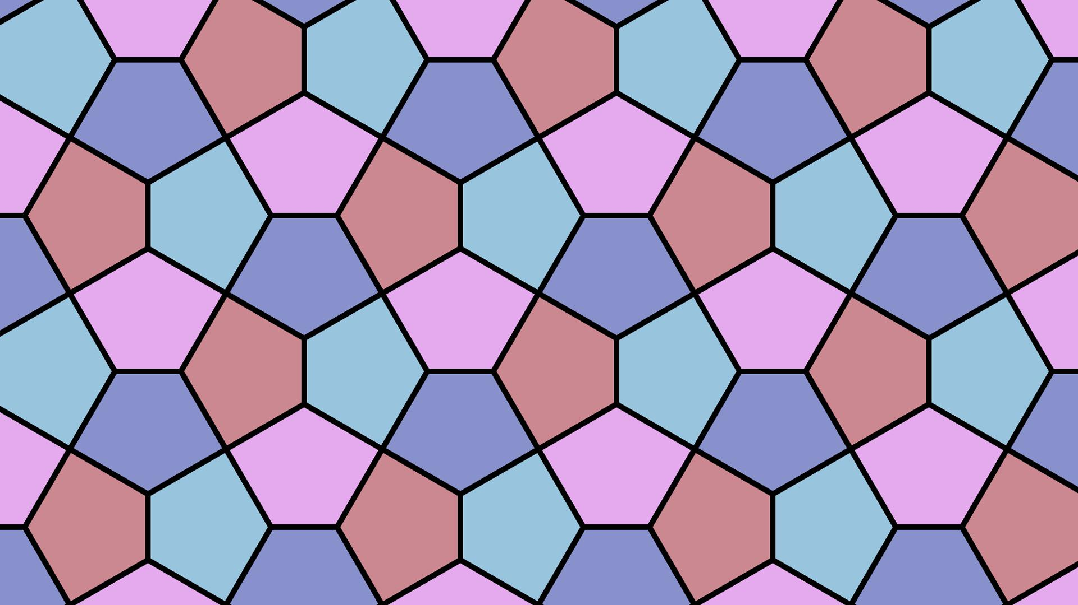
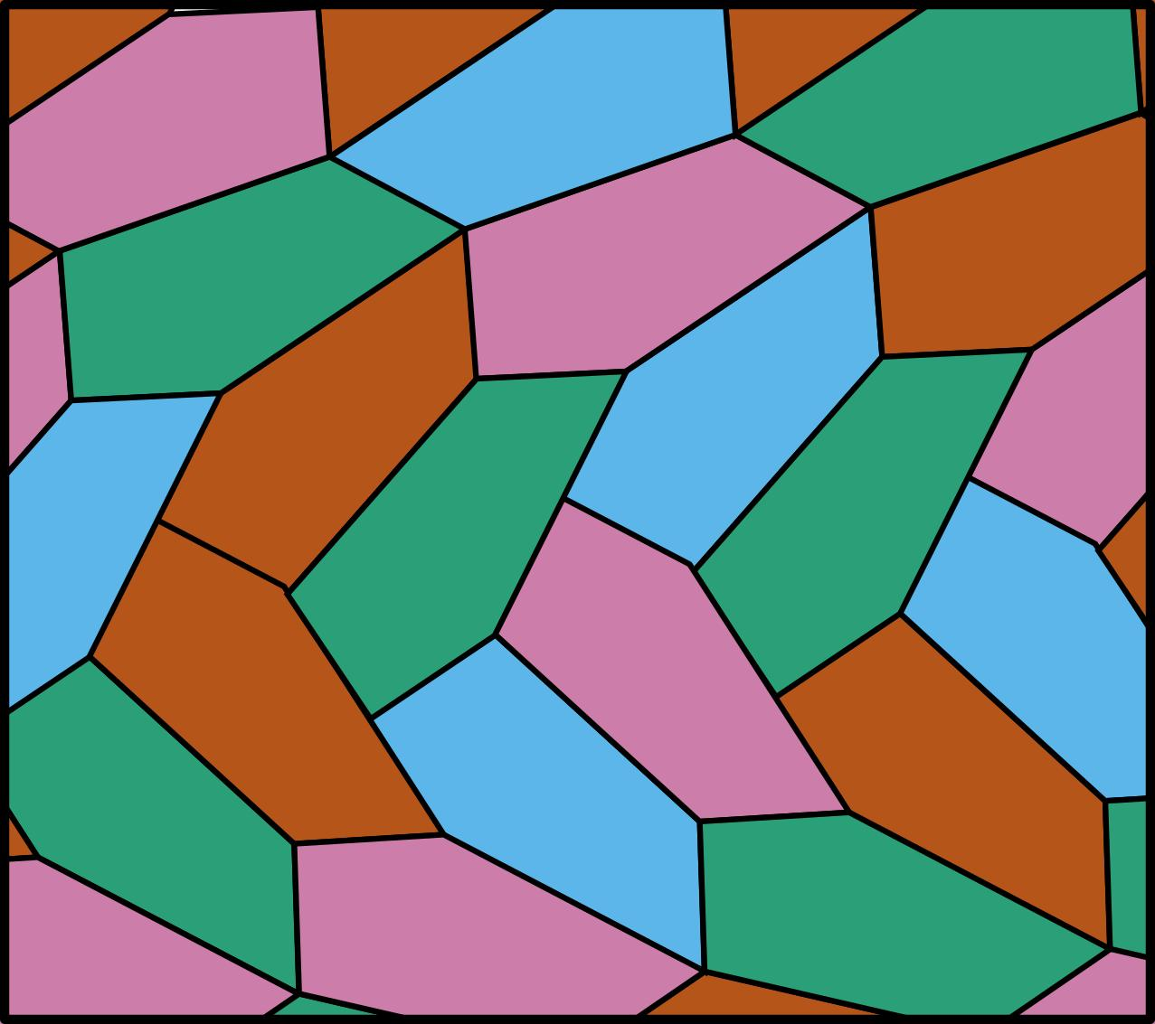
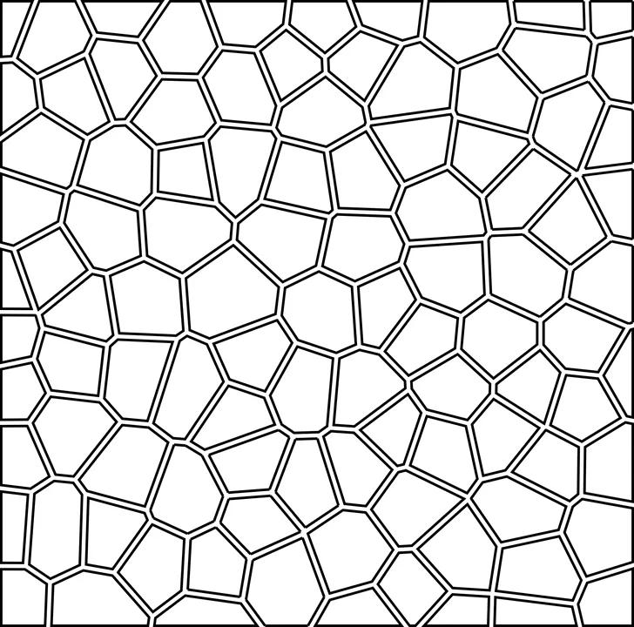
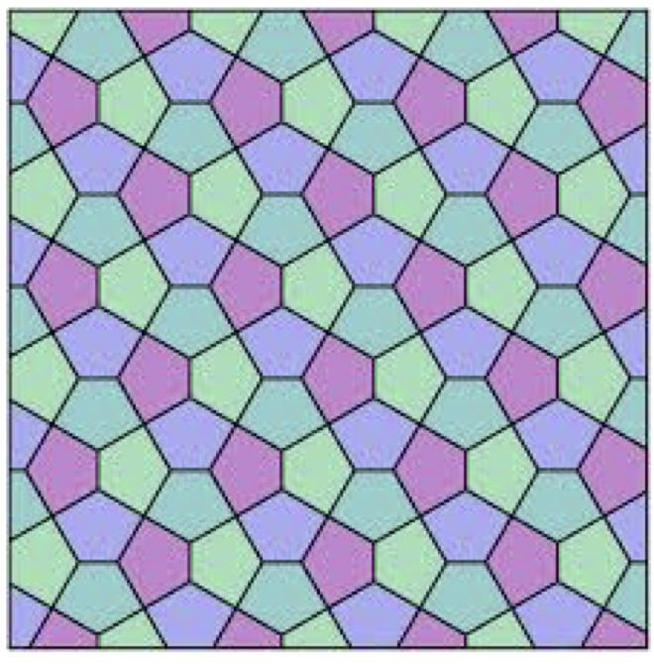
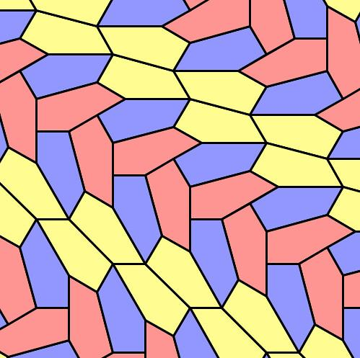
Many different irregular tessellations are possible.

4. Periodic Tessellation
# Source: AI Source: Provided by: [Data Path: Persons Table -> ID Column: 1, Name_En Column: Motasem Essam] -> From: [ChatGPT] on [7/25/2026]
A Periodic Tessellation has a repeating pattern that can be translated to reproduce the entire tessellation.
For example:
ABABABAB...
or a two-dimensional repeating unit:
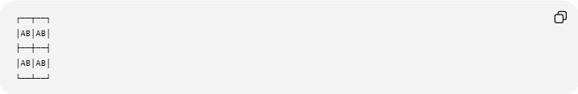
┌──┬──┐
│AB│AB│
├──┼──┤
│AB│AB│
└──┴──┘
The smallest repeating portion is called a fundamental region or unit cell, depending on the context.

5. Non-Periodic Tessellation
# Source: AI Source: Provided by: [Data Path: Persons Table -> ID Column: 1, Name_En Column: Motasem Essam] -> From: [ChatGPT] on [7/25/2026]
A Non-Periodic Tessellation does not repeat according to a simple translational repeating unit.
The classic example is a Penrose tiling.
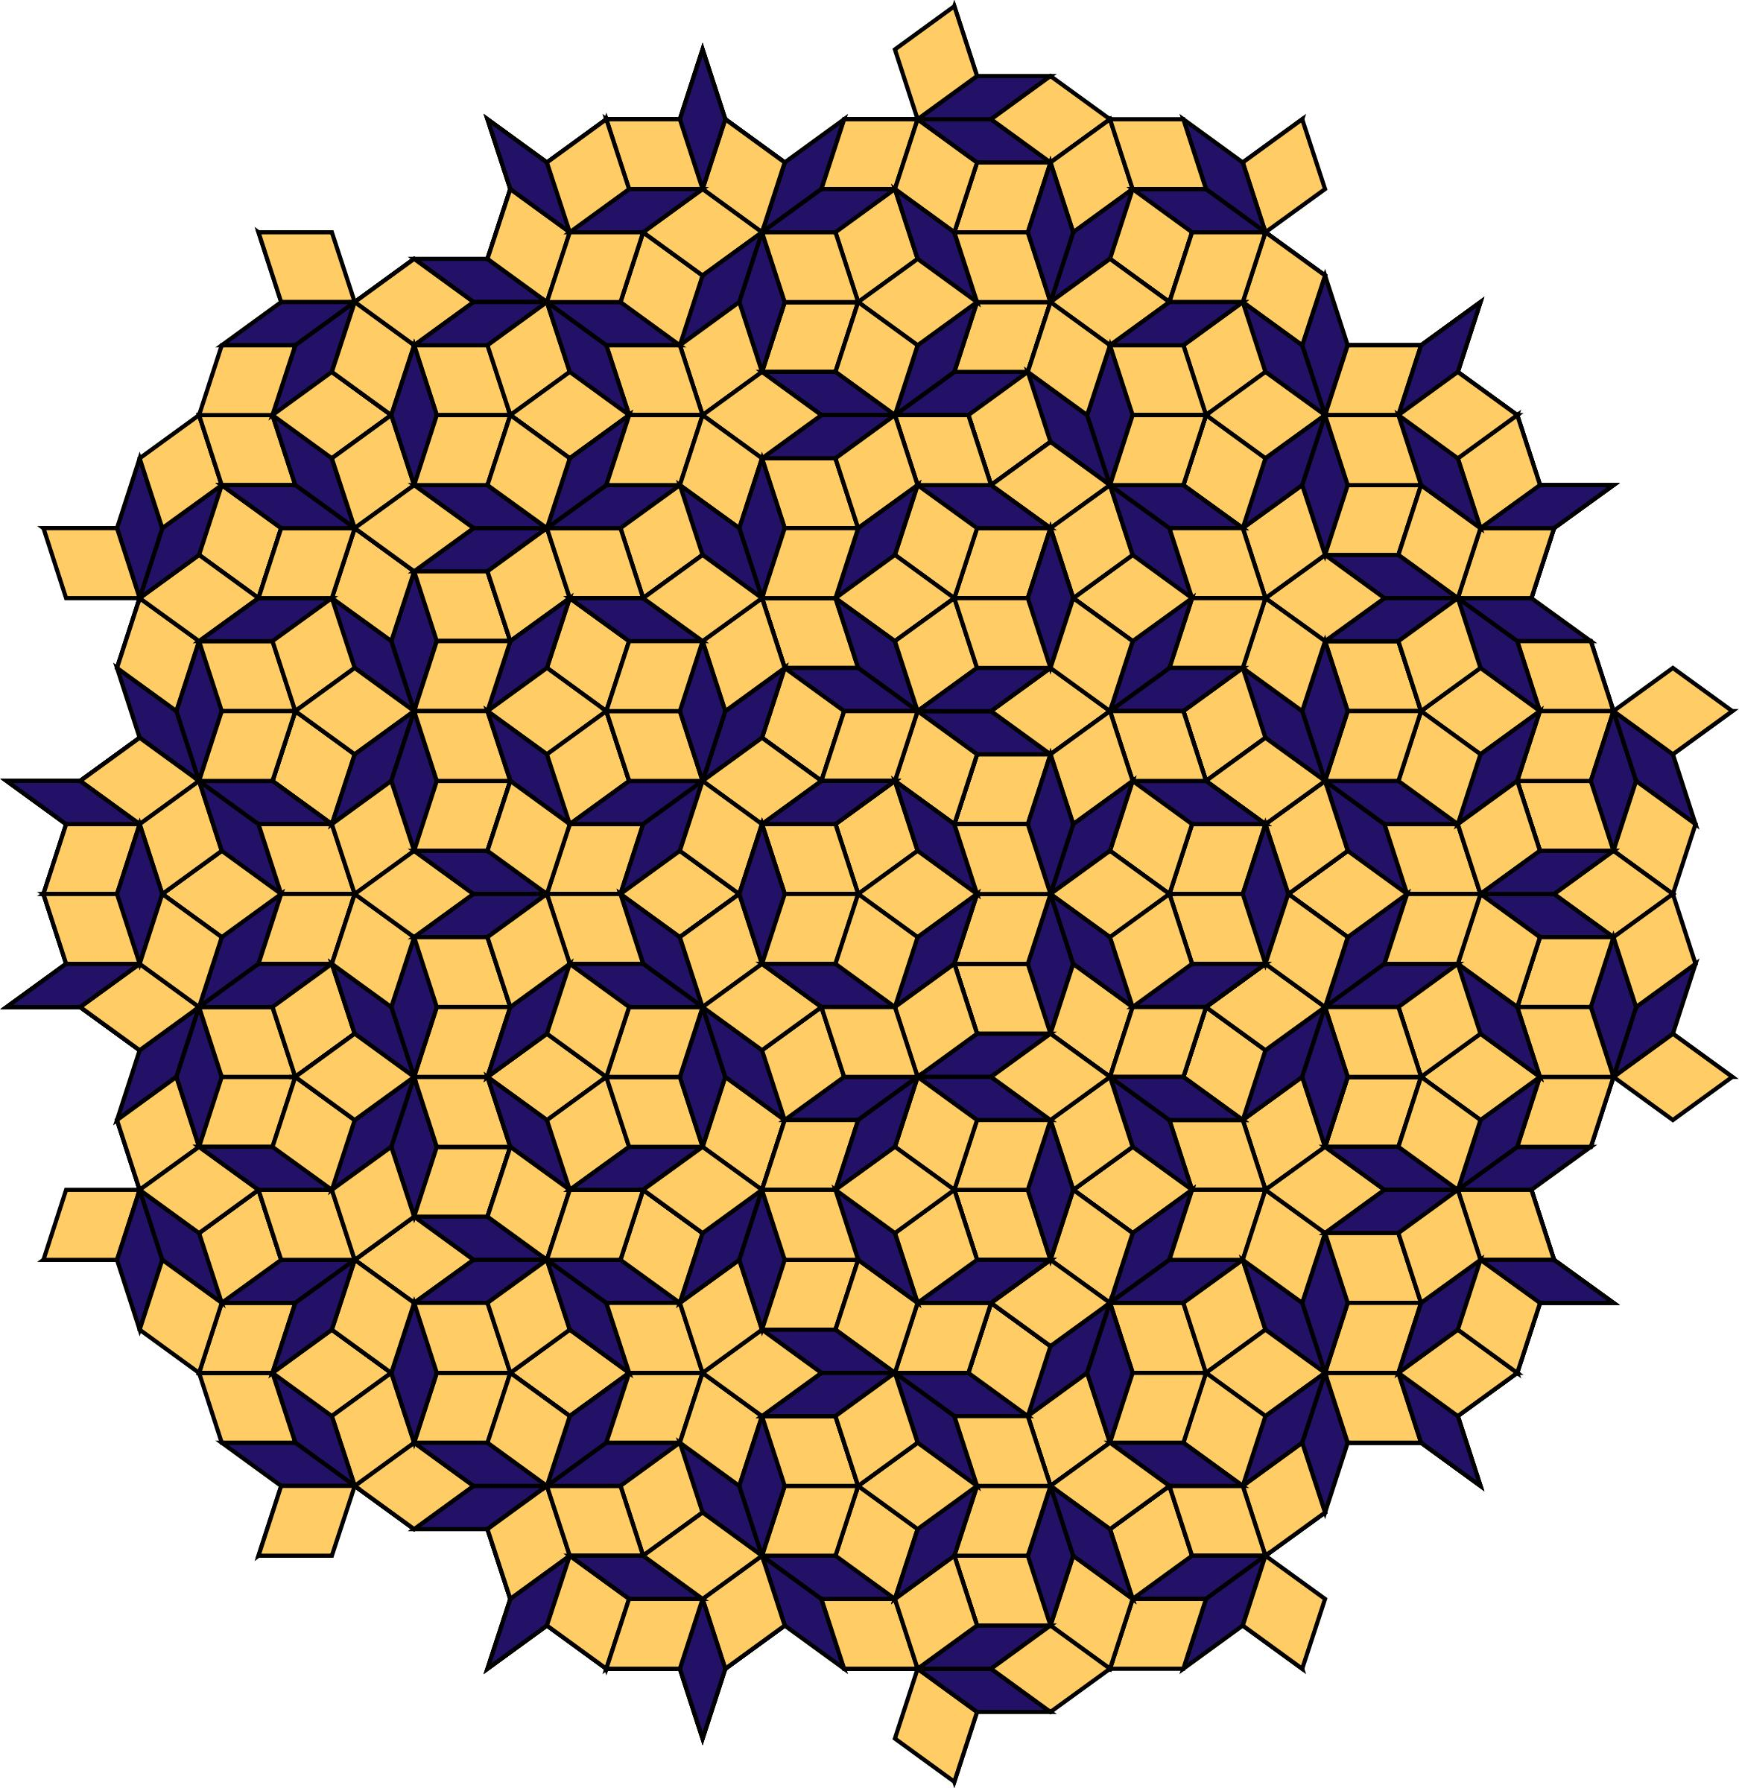
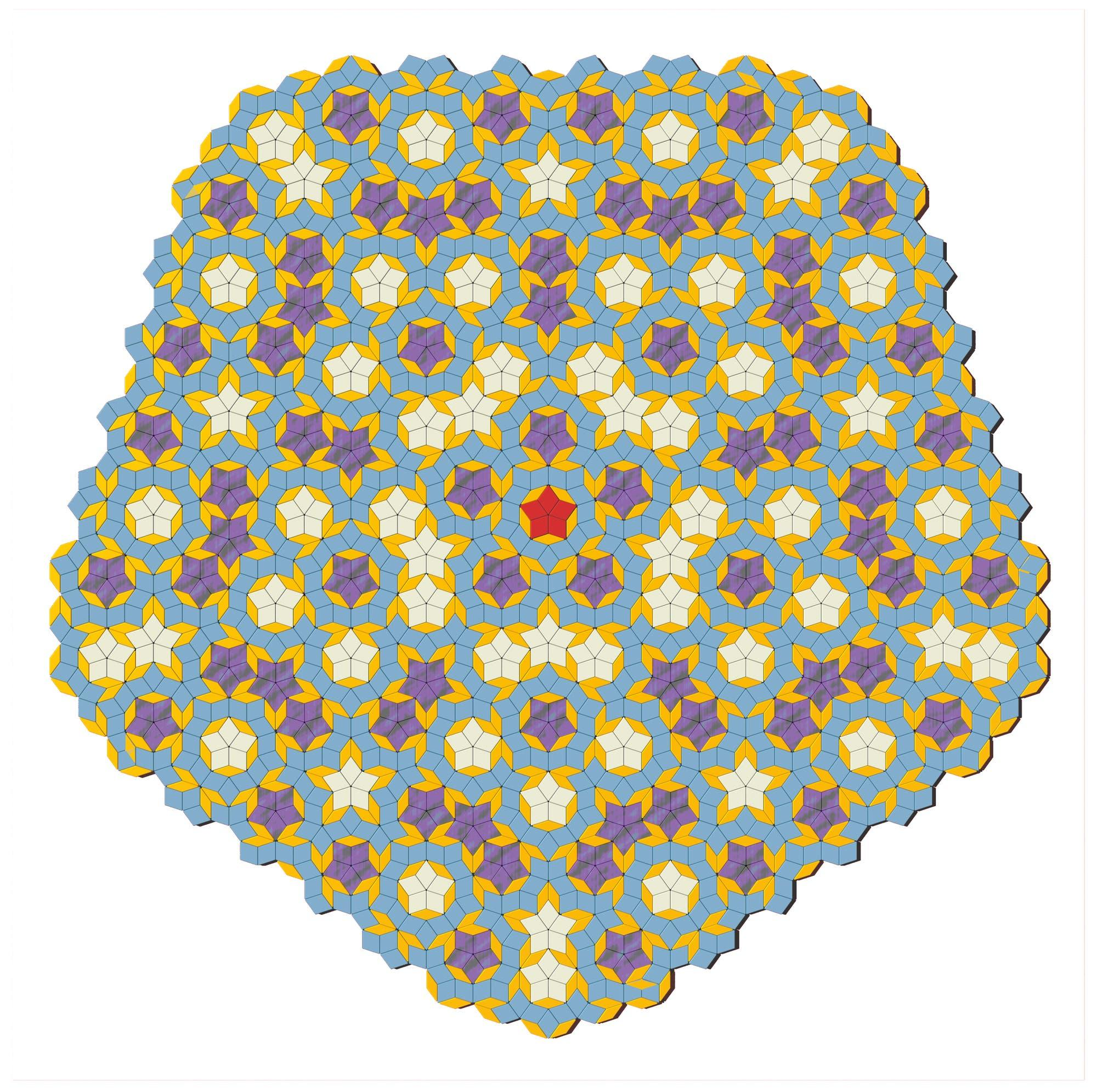
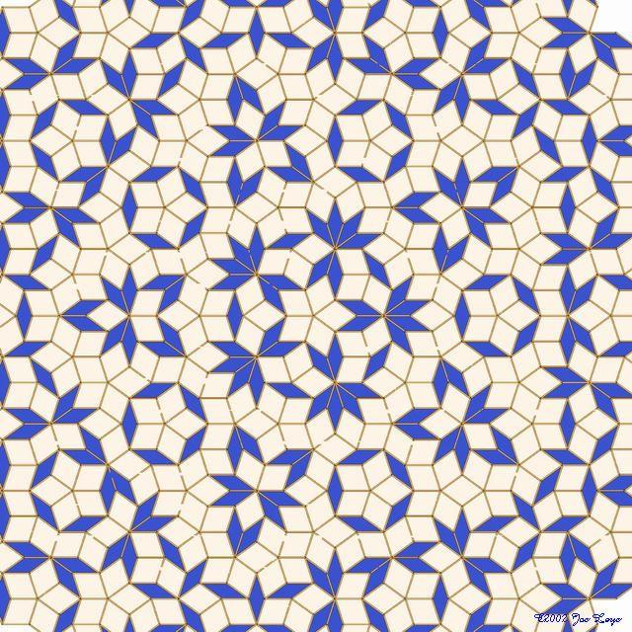
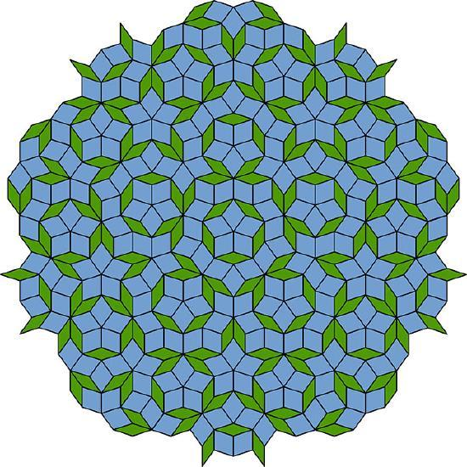
It can cover the plane indefinitely without gaps or overlaps while lacking ordinary translational periodicity.

Regular Polygon Angle Test
# Source: AI Source: Provided by: [Data Path: Persons Table -> ID Column: 1, Name_En Column: Motasem Essam] -> From: [ChatGPT] on [7/25/2026]
For a regular polygon with $n$sides, each interior angle is:
$$\boxed{\frac{\left(n-2\right){180}^{∘}}{n}}$$
If $k$identical regular polygons meet at a vertex, then:
$$k\frac{\left(n-2\right){180}^{∘}}{n}={360}^{∘}$$
Therefore:
$$\boxed{k=\frac{2n}{n-2}}$$
For $k$to be an integer, only three regular polygons work:
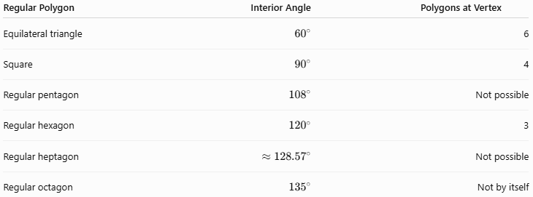
Regular Polygon | Interior Angle | Polygons at Vertex
Equilateral triangle | $${60}^{∘}$$ | 6
Square | $${90}^{∘}$$ | 4
Regular pentagon | $${108}^{∘}$$ | Not possible
Regular hexagon | $${120}^{∘}$$ | 3
Regular heptagon | $$≈{128.57}^{∘}$$ | Not possible
Regular octagon | $${135}^{∘}$$ | Not by itself
Thus:
$$\boxed{\text{There are exactly 3 regular tessellations}}$$

Symmetry in Tessellations
# Source: AI Source: Provided by: [Data Path: Persons Table -> ID Column: 1, Name_En Column: Motasem Essam] -> From: [ChatGPT] on [7/25/2026]
Tessellations can have several types of symmetry.
Translation Symmetry
A pattern can be shifted by a certain distance and remain unchanged.
Reflection Symmetry
A reflection across a line produces the same pattern.
Rotational Symmetry
A tessellation can be rotated around a point and remain unchanged.
Glide Reflection
A reflection followed by a translation produces the same pattern.
These symmetries are important in the mathematical study of repeating patterns.

Examples

Example 1 — Squares
# Source: AI Source: Provided by: [Data Path: Persons Table -> ID Column: 1, Name_En Column: Motasem Essam] -> From: [ChatGPT] on [7/25/2026]
Four squares meet at each vertex:
$$4×{90}^{∘}={360}^{∘}$$
Therefore, squares form a regular tessellation.

Example 2 — Equilateral Triangles
# Source: AI Source: Provided by: [Data Path: Persons Table -> ID Column: 1, Name_En Column: Motasem Essam] -> From: [ChatGPT] on [7/25/2026]
Six triangles meet at every vertex:
$$6×{60}^{∘}={360}^{∘}$$
Therefore, equilateral triangles form a regular tessellation.

Example 3 — Regular Pentagons
# Source: AI Source: Provided by: [Data Path: Persons Table -> ID Column: 1, Name_En Column: Motasem Essam] -> From: [ChatGPT] on [7/25/2026]
Three pentagons would give:
$$3×{108}^{∘}={324}^{∘}$$
leaving:
$${360}^{∘}-{324}^{∘}={36}^{∘}$$
Four pentagons would give:
$$4×{108}^{∘}={432}^{∘}$$
which is too large.
Therefore, regular pentagons cannot form a regular tessellation by themselves.

Tessellation vs Tiling
# Source: AI Source: Provided by: [Data Path: Persons Table -> ID Column: 1, Name_En Column: Motasem Essam] -> From: [ChatGPT] on [7/25/2026]
The terms are closely related.
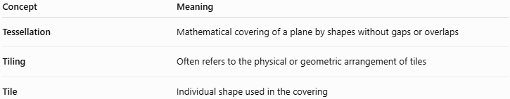
Concept | Meaning
Tessellation | Mathematical covering of a plane by shapes without gaps or overlaps
Tiling | Often refers to the physical or geometric arrangement of tiles
Tile | Individual shape used in the covering
In geometry, tessellation is the more precise mathematical term when discussing plane coverings.

Real-World Applications
# Source: AI Source: Provided by: [Data Path: Persons Table -> ID Column: 1, Name_En Column: Motasem Essam] -> From: [ChatGPT] on [7/25/2026]
Tessellations appear in:
- Floor tiles
- Wall tiles
- Brick arrangements
- Pavement
- Architecture
- Islamic geometric patterns
- Decorative art
- Textile patterns
- Computer graphics
- Crystallography
- Surface design
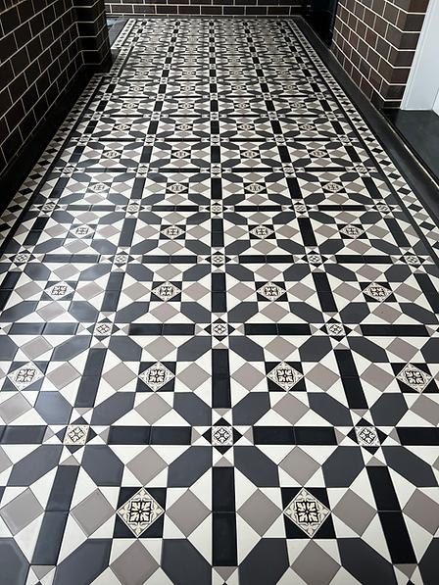
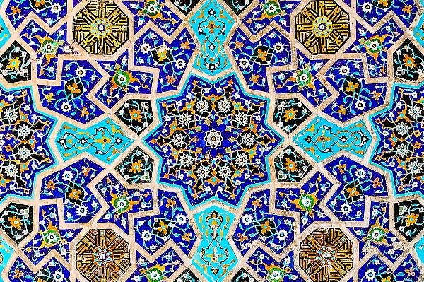
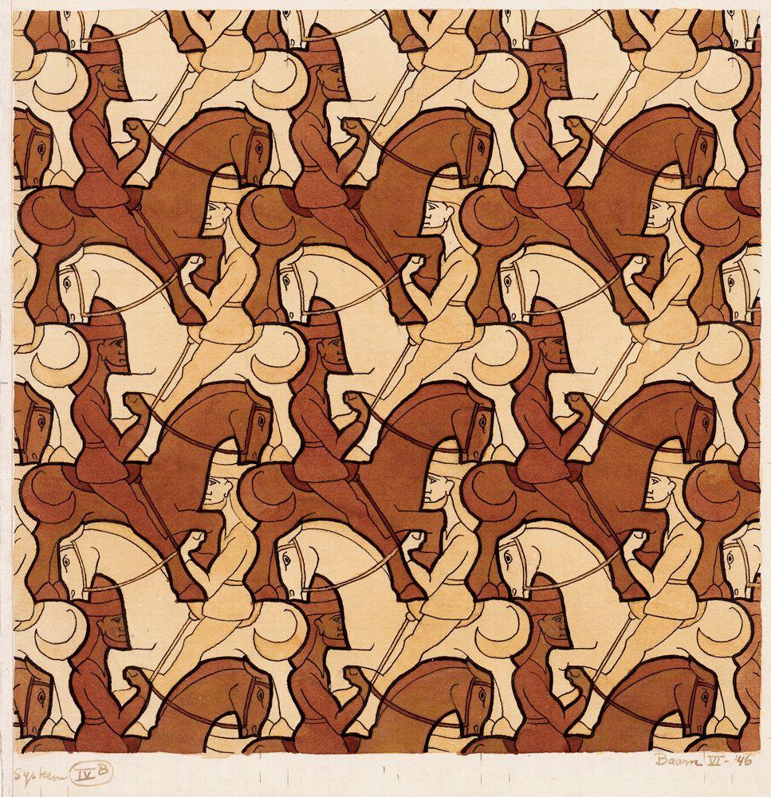
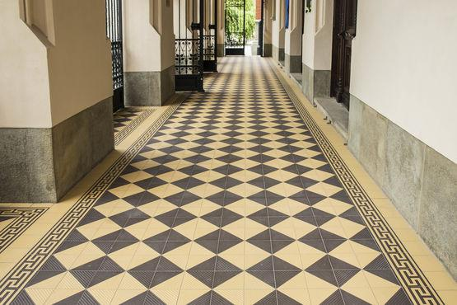
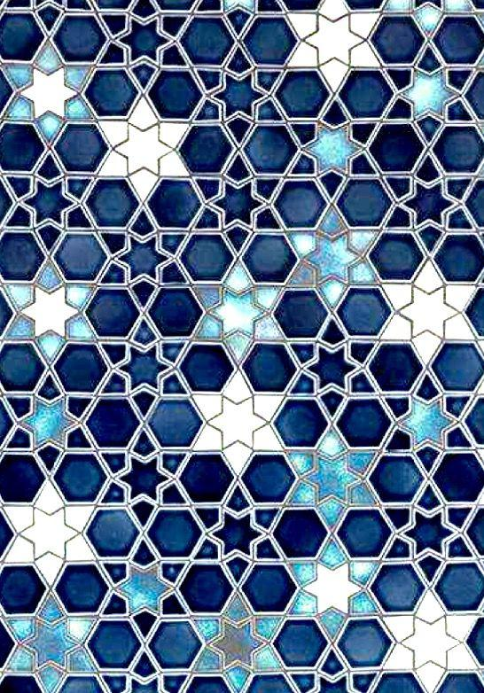

Relationship with Other Geometry Concepts
# Source: AI Source: Provided by: [Data Path: Persons Table -> ID Column: 1, Name_En Column: Motasem Essam] -> From: [ChatGPT] on [7/25/2026]
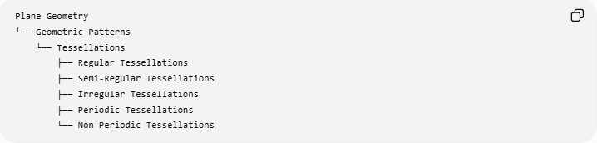
Plane Geometry
└── Geometric Patterns
└── Tessellations
├── Regular Tessellations
├── Semi-Regular Tessellations
├── Irregular Tessellations
├── Periodic Tessellations
└── Non-Periodic Tessellations
Tessellations are closely related to:
- Polygons
- Regular polygons
- Angles
- Symmetry
- Transformations
- Translations
- Rotations
- Reflections
- Glide reflections
- Plane geometry

Key Points
# Source: AI Source: Provided by: [Data Path: Persons Table -> ID Column: 1, Name_En Column: Motasem Essam] -> From: [ChatGPT] on [7/25/2026]
- A tessellation covers a plane without gaps or overlaps.
- The repeated shapes are called tiles.
- The angles around an interior vertex total:
$$\boxed{{360}^{∘}}$$
- There are exactly three regular tessellations:
  - Equilateral triangles
  - Squares
  - Regular hexagons
- Tessellations may use regular or irregular polygons.
- Tessellations can be periodic or non-periodic.
- Symmetry and transformations play an important role in tessellation patterns.

Conclusion
# Source: AI Source: Provided by: [Data Path: Persons Table -> ID Column: 1, Name_En Column: Motasem Essam] -> From: [ChatGPT] on [7/25/2026]
A Tessellation is a geometric covering of a plane using repeated shapes that fit together without gaps or overlaps. It provides an important connection between polygons, angles, symmetry, transformations, and geometric patterns, and it has applications ranging from pure mathematics to architecture and art.
Would you like a simple example of a tessellation using equilateral triangles, squares, or hexagons?

